

Revision History:

|  |  |  |
| --- | --- | --- |
| ***Revision History*** | ***Date*** | ***Comments*** |
| 1.00 |  |  |
| 2.00 |  |  |
|  |  |  |

Document Approval:

The following document has been accepted and approved by the following:

|  |  |  |
| --- | --- | --- |
| ***Signature*** | ***Date*** | ***Name*** |
|  |  |  |
|  |  |  |
|  |  |  |

List of Contents

1 INTRODUCTION..............................................................................................................6

1.1. PURPOSE........................................................................................................................6

1.2. PRODUCT SCOPE..........................................................................................................6

2 OVERVIEW.......................................................................................................................7

2.1 THE OVERALL DESCRIPTION...................................................................................7

2.2 PRODUCT PERSPECTIVE............................................................................................8

2.3. PRODUCT FUNCTIONS...............................................................................................8

2.4. USER CHARACTERISTICS..........................................................................................8

2.5. CONSTRAINTS..............................................................................................................9

2.6. ASSUMPTIONS AND DEPENDENCIES.....................................................................9

3 STATE OF THE ART.....................................................................................................10

4 USER/SYSTEM REQUIREMENTS.............................................................................12

4.1 External Interface Requirements....................................................................................13

4.1.1 User Interfaces.......................................................................................................13

4.1.2 Hardware Interfaces...............................................................................................14

4.1.3 Software Interfaces................................................................................................14

4.1.4 Communication Interfaces.....................................................................................15

5 Functional Requirements................................................................................................15

5.1 Functional Requirements with Traceability information...............................................15

6 Nonfunctional Requirements & Software System Attributes......................................20

6.1 Performance Requirements............................................................................................20

7 Project Design/Architecture ............................................................................................23

List of Figures

Figure 1 Use Case View..................................................................................................................23  
Figure 2 Logical View.....................................................................................................................24  
Figure 3 Process View.....................................................................................................................24

Figure 4 Deployment View.............................................................................................................25  
Figure 5 Physical View...................................................................................................................26  
Figure 6 User Interface Design.......................................................................................................26

List of Tables

Table 1 Terms and Description........................................................................................................7  
Table 2 Terms and Description......................................................................................................16  
Table 3 Terms and Description......................................................................................................17  
Table 4 Terms and Description......................................................................................................17  
Table 5 Terms and Description......................................................................................................18  
Table 6 Terms and Description......................................................................................................18  
Table 7 Terms and Description......................................................................................................19  
Table 8 Terms and Description......................................................................................................19  
Table 9 Terms and Description......................................................................................................20  
Table 10 Terms and Description....................................................................................................20  
Table 11 Terms and Description....................................................................................................21

**1. INTRODUCTION**

"Intelli-Recruit" is a cloud-based AI web application that uses Large Language Models (LLMs) to accelerate recruitment processes. It eliminates resume parsing, initial interviews, personality interviews, and technical interviews. Applicants can select their desired job and interact with a chatbot to give an interview based on their experience, skills, and personality. This makes the recruitment process smoother and faster, as recruiters can view the applicant's report and profile, making decisions based on the interview outcome. The project aims to achieve this milestone.

LLMs are AI systems that generate human-like text, making them powerful tools for natural language processing (NLP). They are built on deep learning techniques, particularly transformer architectures, and have key characteristics like immense size, pre-training, fine-tuning, versatility, and the ability to generate coherent and contextually relevant text. LLMs can be fine-tuned for tasks like text generation, translation, and sentiment analysis. They are valuable for content generation, chatbots, and creative writing applications. However, they face ethical concerns, language biases, and potential misuse. Despite these challenges, LLMs have revolutionized natural language processing and continue to advance AI's capabilities in understanding and generating human language.

**1.1 PURPOSE**

The primary goal of “Intelli-Recruit” is to provide a platform that accelerates the recruitment process of companies. This includes storing a user profile, allowing companies to post jobs, aligning applicants to the jobs that best fit their skills, giving the user the choice of selecting different jobs, conducting their interview comprising of an evaluation of their experience, skills, and personality, saving the interview reports, and last but not least recommending profiles to recruiters based on the applicant’s profile and interview report. This will help streamline the recruitment process and make it faster than ever. The applicant will be interacting with the Chatbot in order to give an interview but it will feel like any other normal interview.

The target audience for this document includes the system development team, project stakeholders, and end-users who will interact with our system. This document is made with the intention of serving as a reference for understanding the requirements and expected features of the system and will guide the design, development, testing, and deployment phases of the project.

**1.2 PRODUCT SCOPE**

“Intelli-Recruit” will be an integral alternative to the otherwise slow and tedious recruitment process. The system will provide a range of operations that will help accelerate the recruitment process. These are:

**i) Resume Parsing Alternative:** The user will be allowed to create a profile and enter all the details that are put inside a resume through a form provided by our software. This will remove the hassle of creating a resume parser and getting rid of data integrity problems.

**ii) Initial Interview Automation:** The user/applicant will be allowed to give an interview with an interactive chatbot interface which will evaluate a user’s experience, skills, and personality.

**iii) Profile and Interview Report:** The company/recruiter will be allowed to view the applicants’ profiles and interview reports generated by our software based on the applicant’s interview.

**iv) Job Recommendations:** The system will be using a recommender system in order to match a user with their desired job based on the skills they possess.

**v) Applicant Recommendations:** The system will also be recommending applicants based on their previous and current interview reports and their respective skills.

**Table 1: Terms used in this document and their description.**

|  |  |
| --- | --- |
| Name | Description |
| 1. SRS | Software Requirement Specification |
| 2. UI | User Interface |
| 3. API | Application Programming Interface |
| 4. FR | Functional Requirement |
| 5. AI | Artificial Intelligence |
| 6. LLM | Large Language Models |
| 7. NLP | Natural Language Processing |
| 8. BEI | Behavourial Event Interview |
| 9. POS | Parts Of Speech |
| 10. TF | Term Frequency |
| 11. IDF | Inverse Document Frequency |
| 12. JWT | Javascript Web Tokens |
| 13. AWS | Amazon Web Services |

**2. OVERVIEW**

**2.1. THE OVERALL DESCRIPTION**

A web application designed to streamline and enhance the job interview and screening process. It works by collecting pertinent job-related information from applicants and leveraging a chatbot to create and administer interview questions. These responses are then assessed, resulting in a more efficient and effective hiring procedure. The primary goal of it is to improve the efficiency and effectiveness of job interviews. Through automation, it aims to save time and resources for organizations while ensuring fairness and consistency in candidate evaluations.

Key features include data collection from applicants, the use of large language model for interview question generation, and using a chatbot for interview administration, response evaluation, and feedback provision. This holistic approach benefits both applicants and hiring managers.

For organizations, this service offers efficiency gains, consistent evaluations, data-driven decision-making, and a faster time-to-hire. Applicants benefit from an improved interview experience, feedback for improvement, and a more equitable hiring process. Our target audience encompasses organizations of all sizes, hiring managers, HR professionals, and job seekers.

In conclusion, IntelliRecruit aims to revolutionize the job interview process, making it faster, fairer, and more data-driven.

**2.2. PRODUCT PERSPECTIVE**

IntelliRecruit is a web-based application meticulously engineered to optimize and modernize the job interview process. It operates within the context of job recruitment and human resources management systems, providing unique technical functionalities while maintaining a standalone presence within the recruitment ecosystem.

**1. System Architecture**

IntelliRecruit adopts a client-server architecture. The client-side application is developed using the ReactJS library to ensure cross-platform compatibility. The server-side components are designed to run on various operating systems and interact with AWS cloud as the primary database management system.

**2. Unique Features**

IntelliRecruit's standout feature is its integration of a chatbot-driven interview process. This chatbot, hosted on the server, conducts interviews with applicants, records responses, and assists hiring managers in the evaluation process. The application incorporates objective evaluation criteria and scoring mechanisms to facilitate unbiased candidate assessments.

**3. Technical Standards and Data Security**

IntelliRecruit strictly adheres to industry-standard security protocols. It employs data encryption, robust authentication, and authorization mechanisms to uphold the confidentiality and integrity of sensitive user and interview data.

**4. Scalability and Standalone Operation**

IntelliRecruit is meticulously designed for scalability, to accommodate a growing user base and increased interview loads without compromising performance.

**5. User Interface**

IntelliRecruit's user interface (UI) adheres to responsive design principles, ensuring optimal usability across various devices and screen sizes.

**2.3. PRODUCT FUNCTIONS**

• Users/client have the authority to register for an account.

• Users/client have authority to create detailed profiles, providing personal information, qualifications, and work experience as they see fit.

• Admin has authority to access the user provided data.

• User have the authority to initiate interviews, with the chatbot facilitating the process by presenting questions in a conversational manner.

• Admin has the authority of users by meticulously recording and storing applicant responses to interview questions.

• Users have authority to access detailed reports and analytics on their performance and interview outcomes to inform their choices.

• Admin have authority in managing user roles, permissions, and access levels, ensuring security and control.

**2.4. USER CHARACTERISTICS**

1. Applicants (Freelancers/Job Seekers):

Role: Applicants are individuals seeking job opportunities and career advancement.

2. Hiring Managers and HR Professionals (Clients/Users):

Role: Hiring managers and HR professionals represent organizations looking to recruit and hire qualified candidates.

3. Administrators (Admins):

Role: Administrators are responsible for overseeing and managing the Iplatform.

**2.5. CONSTRAINTS**

This system is provisioned to be built on the Django framework which is highly flexible. Regarding the database we are working on AWS Cloud Storage. We have decided to use JWTs in this project for authentication.

**2.6. ASSUMPTIONS AND DEPENDENCIES**

**Assumptions:**

• It will be designed with a user-friendly interface to ensure ease of use for all types of users, including applicants, hiring managers, and administrators.

• The application is assumed to rely on Graphical User Interfaces (GUIs) to facilitate user interactions. Users will engage with the system through intuitive and visually appealing interfaces.

• It is assumed that users must provide the correct username and password to access their accounts and execute operations. Security is built on the assumption of proper user authentication.

**Hardware Dependencies:**

**Servers:** The system will require cloud infrastructure to host the application and handle the processing and storage needs. The hardware should have sufficient processing power, memory, and storage capacity to support the system's requirements.

**Network Infrastructure:** A reliable and robust network infrastructure is necessary to ensure smooth communication between users and the system. This includes routers, switches, firewalls, and network cables to establish connectivity and facilitate data transfer.

**Client Devices**: Users will access the system from their respective client devices, such as desktop computers and laptops. The hardware should meet the minimum system requirements of modern usage.

**Software dependencies:**

**Database Management System:** This relies on AWS Cloud Storage as the chosen database management system. Therefore, the availability and proper functioning of AWS Cloud servers are crucial for data storage and retrieval.

**Integration Tools:** It depends on the integration of JWTs to provide certain functionalities. Availability and proper configuration of these APIs are essential for the smooth operation of these features.

**Development Frameworks and Libraries:** The HCM system may be built on specific development frameworks and libraries. Examples include .NET Framework, Java, Ruby on Rails, or Node.js. The dependencies should be installed and configured to support the system's development and runtime environment.

**3. STATE OF THE ART**

AI Chatbot is a widely used application globally in the industrial automation era to enhance growth and efficiency. Chatbots are increasingly utilized across various industries including hospitality, e-commerce, healthcare, education, information technology, financial and legal, and recruitment. The recruitment industry has seen a surge in the use and adaptation of recruitment chatbots, particularly in virtual recruitment, following the COVID-19 pandemic.

**3.1. LITERATURE REVIEW**

This literature review aims to provide an overview of the existing research and key findings in the field. A systematic search of academic databases and relevant sources was conducted using keywords such as "Interview Bots" "AI in Recruitment" and “Interviews conducted by AI”. Despite the growing research and interest in AI-based interview systems, this literature review identifies the several gaps and limitations. The literature review highlights the potential of AI-based interview systems to revolutionize HR practices. The following will provide you a brief discussion of the latest research works done in this field.

**1. Interview Bot Development with Natural Language Processing and Machine Learning**

This study (Siswanto, 2022) proposes the development of an interview bot using Artificial Intelligence and Natural Language Processing technologies to streamline competency assessments, reduce interviewer bias, and facilitate remote interviews in a post-pandemic world. The AI-tuned algorithm, specifically tailored for competency assessment in Indonesian, aims to enhance accuracy, efficiency, and reduce costs and bias while facilitating remote interviews, particularly in the post-pandemic world.

This study presents the development of an interview bot using the Behavioral Event Interview (BEI) method in Indonesian, aiming to assess competency levels while streamlining the interview process. The system uses a facial monitoring camera and goes through three stages: introduction, competency assessment, and validation and closure. The introduction involves greeting the interviewee, explaining the process, and asking validation questions based on the STAR structure. The competency assessment stage involves asking open questions and analyzing responses to determine competency levels. The final stage involves presenting competency level descriptions and ensuring data confidentiality. The development process follows standard AI engineering procedures, including training and evaluating model outputs.

The interview bot's data training process uses Natural Language Processing (NLP) and statistical analysis techniques. It uses datasets from BEI responses and applications, including competency level scores from certified professional assessors. The process starts with tokenization, followed by Bayesian inference, data cleaning, and reduction. Stemming converts words to their basic forms, while POS tagging determines word roles. TF is calculated for competency keywords, with more frequent words receiving higher weight. TF and IDF are used for feature extraction, forming the applied model in the training process.

The interview bot for Indonesian was developed using Natural Language Processing (NLP) and machine learning techniques to process responses and predict competency scores. Two sets of data were prepared for testing: Set A, consisting of 52 interactions with the bot application, and Set B, consisting of 1153 historical records from written BEI competency mapping. The initial study had 1205 complete datasets, with Data A representing respondents familiar with computer interaction and Data B representing respondents of varying ages and cultural backgrounds in government offices. The data was augmented with expert assessor labels for experimentation using the split-half concept, determining result characteristics and accuracy.

The AI-based interview bot evaluates participant responses and assigns competency values, comparing them with human expert assessments. If there's a significant difference, the robot's mapping capability is deemed inadequate. However, a small difference indicates the robot's proficiency in competency assessments. The results show four accurate assessments and two inaccurate ones, with an accuracy rate of 66.7%. The experiments use different data groups, such as training and testing data, to analyze the learning model's characteristics, providing insights into the learning process and accuracy.

**2. Automated Interview Evaluation using Rule based Chatbot**

This study (Dr. S.K Wagh, 2019) discusses the importance of job interviews in evaluating candidates for employment, emphasizing the need for proper preparation and addressing potential missed opportunities. It defines job interviews as formal consultations to assess qualifications, considering factors beyond just answers like communication skills and expressiveness. It raises concerns about bias based on factors like caste, creed, race, religion, and color, emphasizing the need for fair and unbiased candidate assessment. To address these issues, the passage proposes the development of a Software as a Service (SAAS) application that evaluates candidates based on their answers, sentiment, and emotional expressions during interviews, with a chatbot acting as a conversation agent.

The proposed system focuses on two tasks: Emotion Detection and Questions Dataset for Chatbot. Emotion detection uses the FER+ dataset, which contains over 3000 images tagged by 10 different taggers, and aims to identify emotions in images. The Chatbot dataset, created without an existing interview question dataset, includes 1928 questions categorized into technical and non-technical groups. The questions were collected using a web scraping tool and manual curation to assign categories and subcategories.

**3. Interview Bot for Improving Human Resource Management**

This study (Suakanto, 2021) investigates the feasibility of employing a chatbot for the interview process, an area where chatbot application has seen limited discussion despite its rapid evolution in various fields. While chatbots have been widely adopted for efficient data collection in customer service, healthcare, and other domains, their use in autonomously conducting interviews is relatively unexplored. The study recognizes the limitations of human-driven interviews, such as scalability issues and susceptibility to bias, prompting the development of a chatbot designed specifically for conducting interviews. The research outlines the design of the interview chatbot and explores the integration of Artificial Intelligence (AI) or machine learning for processing interview results. A key contribution of the study is the identification of differences between typical chatbot communication methods and those tailored for interviews, offering insights for the creation of new interview bots or the enhancement of existing chatbot implementations. The paper concludes by discussing both the challenges and benefits associated with the development of interview bots, shedding light on the potential transformative impact of this technology on the interview process.

**4. HR-Chat bot: Designing and Building Effective Interview Chat-bots for Fake CV Detection**

This paper (AbdElminaam, 2021) addresses the challenges faced by Human Resources (HR) departments in managing a large number of job applicants. The primary objective is to assist HR employees in efficiently collecting and organizing information about applicants' personal skills and CV details. The proposed model aims to streamline the process by utilizing a chatbot interview that not only identifies and filters applicants but also detects potential inaccuracies or falsehoods in CV skills. The model suggests the use of facial expression recognition techniques during the virtual interview to gauge applicant reactions. By automating the interview process, the proposed model seeks to reduce the burden on HR employees significantly. Additionally, it emphasizes the reorganization and recommendation of applicants based on the alignment of their personal skills with job requirements. Overall, the model offers a comprehensive solution to enhance the efficiency and accuracy of applicant assessment in the hiring process.

**5. An AI-Based Shortlisting Model for Sustainability of Human Resource Management**

This study (Aydın, 2023) explores the integration of artificial intelligence (AI) into human resource management, particularly focusing on recruitment and shortlisting processes. Recognizing the potential for AI to enhance efficiency and provide a competitive advantage, the research aims to streamline time-consuming tasks, especially in recruitment. The study introduces the application of a minimum description length algorithm to eliminate noisy data from resumes, coupled with a learning algorithm based on support vector machines. The primary goal is to identify and select candidates that align with the company's culture and preferences, thus improving the overall hiring process. The paper emphasizes the unique contribution of employing learning algorithms for resume analysis and presents insights into the performance evaluation results. Notably, the study highlights the success of feature selection in contrast to feature extraction and demonstrates how the learning algorithm contributes to effective shortlisting. This research addresses a gap in the existing literature by providing a detailed exploration of resume-based learning algorithms and their impact on the recruitment process.

**6. VR Job Interview Simulator: Where Virtual Reality Meets Artificial Intelligence for Education**

The study (Stanica, 2018) explores the contemporary challenges faced by individuals during job interviews, including issues related to introversion, insecurity, and deficiencies in technical or social skills. It emphasizes the increasing importance of training to enhance interview performance. This study introduces "VR Job," an innovative application that integrates virtual reality and chatbots to create an interactive training environment specifically designed for software engineers. Notably, the application incorporates emotion recognition techniques, offering users precise feedback on their performance. This novel approach aims to address the multifaceted aspects of interview preparation, leveraging cutting-edge technologies to enhance training effectiveness.

**7. Natural Language Processing based Jaro-The Interviewing Chatbot**

The proposed system (Purohit, 2019), JARO, aims to address challenges faced by recruiters in communicating with and interviewing large volumes of candidates efficiently. JARO is designed to streamline the hiring process by employing a chatbot that conducts interviews based on the analysis of candidates' resumes. The system incorporates features such as resume analysis, automatic interview processes, and utilizes Natural Language Processing (NLP) to ask questions based on candidates' responses. The objective is to accelerate the interview process and enhance decision-making by minimizing inconsistencies related to interview logistics and human factors. After the interview, JARO analyzes the collected data to facilitate unbiased candidate selection for the offered position, ultimately contributing to the efficiency of the recruitment process.

**8. Automated Interview Evaluation using Rule based Chatbot**

The escalating demand for global online recruitment has prompted the development of practical solutions to address the challenges faced by recruiters in managing a surge of applications and maintaining effective communication with applicants. This study (Mhadgut, 2022) introduces "vRecruit - A machine learning-based web application" as a novel approach to virtual recruitment. The key features of vRecruit include a client-specific interview process utilizing Machine Learning-based references aligned with client-provided context and a text-based sentiment analysis engine. These components collaboratively contribute to the end-to-end functionality of the web application, which was successfully launched on Flask. Noteworthy achievements include a 96% accuracy in face recognition using the face API model, a 7.55% word error rate in speech-to-text conversion with the Mozilla DeepSpeech model, and a 95% accuracy in the Rasa Natural Language Understanding (NLU) model trained for chatbots. The comprehensive capabilities of vRecruit promise a seamless and hassle-free virtual recruiting experience for both candidates and interviewers.

**3.2. EXISTING SYSTEMS**

**1. InterviewBot**

Interviewbot is an AI tool that assists users in preparing for interviews by selecting industry-specific questions and practicing with HR questions. Users can choose from various avatars with unique styles and customize their interview prep time from zero seconds to 10 seconds. For those seeking to improve their interview technique, Interviewbot offers subscription options with AI coaching tips. The tool also allows users to playback and re-record interviews for performance review and improvement.

**2. Interviewer.AI**

Interviewer.AI is an AI-powered platform that streamlines the hiring process by automating pre-screening with AI-driven video interviews. It combines résumé screening, assessments, and video interviews to assess core competencies. The platform offers transparent evaluation criteria, saving time for both the hiring team and candidates. In a competitive job market, it can expedite hiring and improve candidate experiences. A free trial allows users to assess its benefits.

**3. TARS**

The platform streamlines candidate screening and interviews by creating detailed profiles and matching candidates with suitable interviewers based on skills and experience. It saves time and energy, enables efficient interviews with multiple candidates, and widens the hiring pool, making it easier to consider candidates with limited information or experience. Overall, it optimizes the hiring process and aids in informed decisions.

**4. USER/SYSTEM REQUIREMENTS**

As there are going to be two main users using this application, both will have different interactions with the application. The recruiter interface will be able to see the applicants’ profiles, their performances, and any messages that they might have sent. Moreover, the HR interface will allow the users to see the shortlisted candidates for a particular job position by the AI. The applicant interface will allow them to see their profile and their performance in their interviews, they will be able to see the suggestions made by the AI for other suitable jobs. The applicant interface will allow the applicants to apply for job roles and give beginner level interviews that will allow the AI to shortlist the candidates based on their skills and personalities.

**4.1. EXTERNAL INTERFACE REQUIREMENTS**

**4.1.1. USER INTERFACES**

**Consistent Design:**

The UI design must maintain consistency across all screens and elements, ensuring a cohesive and visually appealing user experience.

**Intuitive Navigation:**

The navigation within the application should be straightforward, with easily accessible menus, buttons, and links to guide users through various functions.

**Responsive Design:**

The UI must be responsive, adapting to different screen sizes and orientations to provide an optimal viewing experience on both mobile and desktop devices.

**User Authentication:**

Users must be presented with a secure and user-friendly authentication interface to enter their credentials (username and password) for access.

**User Profiles:**

Applicants, and administrators should have individual profiles displaying relevant information and settings. Users can edit and manage their profiles.

**Dashboard:**

A user-specific dashboard should provide an overview of key information, such as interview status, notifications, and recent activity.

**Interview Questionnaire:**

The chatbot-driven interview interface should facilitate a natural conversation between the applicant and the system, with text input and response recording capabilities.

**Evaluation and Feedback:**

Hiring managers should have access to an evaluation interface for reviewing applicant responses and providing feedback. Applicants should receive feedback through their accounts.

**Reports and Analytics:**

A reporting interface should present data and analytics related to candidate performance, interview outcomes, and other relevant metrics.

**Settings and Preferences:**

Users should have access to settings where they can customize preferences, notification settings, and language preferences.

**Error Handling:**

Effective error messages and prompts should guide users in case of input errors or system issues.

**Logout Functionality:**

Users should have a clear and easy way to log out of their accounts to ensure security and privacy.

**4.1.2. HARDWARE INTERFACES**

This is a cloud based web-application strictly based on software. There are no hardware interactions other than the devices that the users already possess. Devices like computers are supported.

**4.1.3. SOFTWARE INTERFACES**

The successful operation of “Intelli-Recruit” depends on various software interfaces and integrations with external systems. These interfaces are essential for the proper functioning and compatibility of the application:

**Operating Systems:**

• This application is designed to run on various operating systems, including Android and iOS for mobile devices, and Windows, macOS, and Linux for desktop devices.

**Web Browsers:**

• The application should be accessible and fully functional on standard web browsers such as Google Chrome, Mozilla Firefox, Microsoft Edge, and Safari.

**Database Management System:**

• This application interacts with AWS Cloud Storage, a cloud based database, for data storage and retrieval. It relies on API for communication with the server.

**Third-Party Libraries and Frameworks:**

• This application may utilize various third-party libraries and frameworks, including those related to user interface design (e.g., React components), and chatbot functionality.

**Email Services:**

• The application may interface with email services (SMTP) to send notifications, confirmations, and communication updates to users via email.

**4.1.4. COMMUNICATION INTERFACES**

Users communicate with software using a pointing device and keyboard. The main communications are always held between the app and the database. REST API will be used to store, retrieve and validate data. This will further include sending and receiving HTTP requests to the database and receiving the HTTP response back from the server.

**5 FUNCTIONAL REQUIREMENTS**

**5.1 FUNCTIONAL REQUIREMENTS WITH TRACEBILITY INFORMATION**

1. **Functional Requirement 1:** The system will allow users to sign into their accounts by entering their email address and password (FR1). Users can register their accounts by providing their credentials. If a user is already registered, they can simply sign in by entering their email address and password. These credentials will be stored in the database and used to authenticate users.

|  |  |  |  |  |  |  |  |  |  |  |  |  |  |  |  |  |  |  |
| --- | --- | --- | --- | --- | --- | --- | --- | --- | --- | --- | --- | --- | --- | --- | --- | --- | --- | --- |
| **Requirement ID** | FR1 | | | **Requirement Type** | | | | Functional | | | | | **Use Case #** | | | | | 1 |
| **Status** | ***New*** | X | ***Agreed-to*** | | | - | ***Baselined*** | | | | - | ***Rejected*** | | | | | - |  |
| **Parent Requirement #** | N/A | | | | | | | | | | | | | | | | | |
| **Description** | Users must register and authenticate prior to using the system. | | | | | | | | | | | | | | | | | |
| **Rationale** | Prevention against unauthorized access | | | | | | | | | | | | | | | | | |
| **Source** |  | | | | | | | **Source Document** | | | | | | - | | | | |
| **Acceptance/Fit Criteria** | User can access to dashboard. | | | | | | | | | | | | | | | | | |
| **Dependencies** |  | | | | | | | | | | | | | | | | | |
| **Priority** | ***Essential*** | | X | | ***Conditional*** | | | | - | ***Optional*** | | | | | - |  | | |
| **Change History** |  | | | | | | | | | | | | | | | | | |

**Table 2: FR1**

2. **Functional Requirement 2:** The system will allow the users to create, edit, and delete their profiles (FR2). The profile can include different kinds of information e.g., skills, education, address, services, etc. Both companies and job seekers can create a profile according to their requirements. This information will help job seekers to land their dream job and companies to hire a competent individual for a particular job. All the job profiles will be saved in the database.

|  |  |  |  |  |  |  |  |  |  |  |  |  |  |  |  |  |  |  |
| --- | --- | --- | --- | --- | --- | --- | --- | --- | --- | --- | --- | --- | --- | --- | --- | --- | --- | --- |
| **Requirement ID** | FR2 | | | **Requirement Type** | | | | Functional | | | | | **Use Case #** | | | | | 1 |
| **Status** | ***New*** | X | ***Agreed-to*** | | | - | ***Baselined*** | | | | - | ***Rejected*** | | | | | - |  |
| **Parent Requirement #** | N/A | | | | | | | | | | | | | | | | | |
| **Description** | Users can create, edit, and delete their profile. | | | | | | | | | | | | | | | | | |
| **Rationale** | The information in the profile will help job seekers and companies to learn about each other and will help the AI chatbot to generate interview questions. | | | | | | | | | | | | | | | | | |
| **Source** |  | | | | | | | **Source Document** | | | | | | - | | | | |
| **Acceptance/Fit Criteria** | Users can create, delete and edit different sections of the profile. | | | | | | | | | | | | | | | | | |
| **Dependencies** |  | | | | | | | | | | | | | | | | | |
| **Priority** | ***Essential*** | | X | | ***Conditional*** | | | | - | ***Optional*** | | | | | - |  | | |
| **Change History** |  | | | | | | | | | | | | | | | | | |

**Table 3: FR2**

3. **Functional Requirement 3:** The system will allow the users to manage job listings (FR3). Companies can post job vacancies by providing information including job description, job type, offered salary, required skills, experience and education, and information about the department and location of the job. They can delete and change the status of the specific job from available to not available as well.

|  |  |  |  |  |  |  |  |  |  |  |  |  |  |  |  |  |  |  |
| --- | --- | --- | --- | --- | --- | --- | --- | --- | --- | --- | --- | --- | --- | --- | --- | --- | --- | --- |
| **Requirement ID** | FR3 | | | **Requirement Type** | | | | Functional | | | | | **Use Case #** | | | | | 1 |
| **Status** | ***New*** | X | ***Agreed-to*** | | | - | ***Baselined*** | | | | - | ***Rejected*** | | | | | - |  |
| **Parent Requirement #** | N/A | | | | | | | | | | | | | | | | | |
| **Description** | Companies can post different jobs along with their different details like job descriptions, offered salary, required experience, etc. They can edit these job details and change the job status from available to not available and can delete a specific job as well. | | | | | | | | | | | | | | | | | |
| **Rationale** | Companies can post different jobs along with their different details to attract potential candidates while maintaining control over the availability of these positions. | | | | | | | | | | | | | | | | | |
| **Source** |  | | | | | | | **Source Document** | | | | | | - | | | | |
| **Acceptance/Fit Criteria** | A company can post different jobs and edit job details any time they want according to their requirements. Any changes made by the company will be visible in real-time. | | | | | | | | | | | | | | | | | |
| **Dependencies** |  | | | | | | | | | | | | | | | | | |
| **Priority** | ***Essential*** | | X | | ***Conditional*** | | | | - | ***Optional*** | | | | | - |  | | |
| **Change History** |  | | | | | | | | | | | | | | | | | |

**Table 4: FR3**

4. **Functional Requirement 4:** The system will allow the users to search for jobs and gain insights into job popularity and demand (FR4). Both the companies and job seekers can view the number of job seekers that have viewed or saved the job posting to review later. This will help the companies and job seekers to learn which job is in demand and popular. Job seekers can also search for different jobs by using keywords like job location, skills required, offered salary, etc.

|  |  |  |  |  |  |  |  |  |  |  |  |  |  |  |  |  |  |  |
| --- | --- | --- | --- | --- | --- | --- | --- | --- | --- | --- | --- | --- | --- | --- | --- | --- | --- | --- |
| **Requirement ID** | FR4 | | | **Requirement Type** | | | | Functional | | | | | **Use Case #** | | | | | 1 |
| **Status** | ***New*** | X | ***Agreed-to*** | | | - | ***Baselined*** | | | | - | ***Rejected*** | | | | | - |  |
| **Parent Requirement #** | N/A | | | | | | | | | | | | | | | | | |
| **Description** | Users can gain insights in the popularity and demand of a particular job by viewing the number of users that have viewed or saved the job posting. | | | | | | | | | | | | | | | | | |
| **Rationale** | By enabling users to search for different jobs and gain insights into the job popularity will help the job seekers to discover relevant opportunities and allowing companies to make necessary adjustments to their recruitment strategies. | | | | | | | | | | | | | | | | | |
| **Source** |  | | | | | | | **Source Document** | | | | | | - | | | | |
| **Acceptance/Fit Criteria** | Users can see which job is in demand by viewing number of users who have viewed the job posting or saved it that will be present in a clear and understandable format. Job seekers will be able to search and filter jobs based on certain criteria such as job type, job location, required experience etc. | | | | | | | | | | | | | | | | | |
| **Dependencies** |  | | | | | | | | | | | | | | | | | |
| **Priority** | ***Essential*** | | X | | ***Conditional*** | | | | - | ***Optional*** | | | | | - |  | | |
| **Change History** |  | | | | | | | | | | | | | | | | | |

**Table 5: FR4**

5. **Functional Requirement 5:** The system will aid job seekers in their job search by providing job recommendations that match their profiles (FR5).

|  |  |  |  |  |  |  |  |  |  |  |  |  |  |  |  |  |  |  |
| --- | --- | --- | --- | --- | --- | --- | --- | --- | --- | --- | --- | --- | --- | --- | --- | --- | --- | --- |
| **Requirement ID** | FR5 | | | **Requirement Type** | | | | Functional | | | | | **Use Case #** | | | | | 1 |
| **Status** | ***New*** | X | ***Agreed-to*** | | | - | ***Baselined*** | | | | - | ***Rejected*** | | | | | - |  |
| **Parent Requirement #** | FR2 | | | | | | | | | | | | | | | | | |
| **Description** | Job seekers can see the job postings whose requirements match their profile. | | | | | | | | | | | | | | | | | |
| **Rationale** | Providing job recommendations to job seekers based on their profile helps them in finding job positions that align with their profile. This recommendation system saves job seekers’ time and helps them discover opportunities they might have missed otherwise. | | | | | | | | | | | | | | | | | |
| **Source** |  | | | | | | | **Source Document** | | | | | | - | | | | |
| **Acceptance/Fit Criteria** | Job seekers can manage their profiles with the passage of time. Job recommendations will be generated based on the profile and they will be updated in real-time to reflect the changes in the profile or the availability of new job listings that match the profile. Job seekers can view the job listings in a user-friendly interface. | | | | | | | | | | | | | | | | | |
| **Dependencies** |  | | | | | | | | | | | | | | | | | |
| **Priority** | ***Essential*** | | X | | ***Conditional*** | | | | - | ***Optional*** | | | | | - |  | | |
| **Change History** |  | | | | | | | | | | | | | | | | | |

**Table 6: FR5**

6. **Functional Requirement 6:** The system will allow job seekers to apply for different jobs according to their requirements easily and quickly (FR4). After applying for a job, the job seekers will receive confirmation of their application and information about their interview.

|  |  |  |  |  |  |  |  |  |  |  |  |  |  |  |  |  |  |  |
| --- | --- | --- | --- | --- | --- | --- | --- | --- | --- | --- | --- | --- | --- | --- | --- | --- | --- | --- |
| **Requirement ID** | FR6 | | | **Requirement Type** | | | | Functional | | | | | **Use Case #** | | | | | 1 |
| **Status** | ***New*** | X | ***Agreed-to*** | | | - | ***Baselined*** | | | | - | ***Rejected*** | | | | | - |  |
| **Parent Requirement #** | N/A | | | | | | | | | | | | | | | | | |
| **Description** | Job seekers can apply for different jobs that meet their requirements and they will receive their application confirmation and information about their interview. | | | | | | | | | | | | | | | | | |
| **Rationale** | Job seekers can easily apply for different jobs and clear information will be provided about their interview which will help them to stay informed and engaged in the recruitment process. | | | | | | | | | | | | | | | | | |
| **Source** |  | | | | | | | **Source Document** | | | | | | - | | | | |
| **Acceptance/Fit Criteria** | Job seekers can apply for different jobs in a very clear and transparent process. They will receive notification regarding their acceptance of the application and will be notified regarding the interview. Job seekers can attempt an interview at their convenience and can decline to take the interview for a certain job. | | | | | | | | | | | | | | | | | |
| **Dependencies** |  | | | | | | | | | | | | | | | | | |
| **Priority** | ***Essential*** | | X | | ***Conditional*** | | | | - | ***Optional*** | | | | | - |  | | |
| **Change History** |  | | | | | | | | | | | | | | | | | |

**Table 7: FR6**

7. **Functional Requirement 7:** The system will provide an opportunity for job seekers to participate in an unbiased interview that will be conducted and evaluated using an AI chatbot (FR7). Job seekers can attempt three kinds of interviews that will test their conceptual and technical skills as well as their personality traits. After the interview, the AI chatbot will generate an evaluation report that can be accessed by job seekers and companies. All the evaluation reports will be saved in the database.

|  |  |  |  |  |  |  |  |  |  |  |  |  |  |  |  |  |  |  |
| --- | --- | --- | --- | --- | --- | --- | --- | --- | --- | --- | --- | --- | --- | --- | --- | --- | --- | --- |
| **Requirement ID** | FR7 | | | **Requirement Type** | | | | Functional | | | | | **Use Case #** | | | | | 1 |
| **Status** | ***New*** | X | ***Agreed-to*** | | | - | ***Baselined*** | | | | - | ***Rejected*** | | | | | - |  |
| **Parent Requirement #** | FR6 | | | | | | | | | | | | | | | | | |
| **Description** | Job seekers can attempt three kinds of interviews for a job posting that will be conducted by an AI chatbot and an evaluation report will be generated at the end by the chatbot. | | | | | | | | | | | | | | | | | |
| **Rationale** | Job seekers can attempt three kinds of interviews that will test their conceptual and technical skills and personality traits. These interviews will be conducted by an AI chatbot to make sure that there is an unbiased system. An evaluation report will be generated at the end of the interviews by AI chatbot which can be viewed by the job seekers to view their performance results. | | | | | | | | | | | | | | | | | |
| **Source** |  | | | | | | | **Source Document** | | | | | | - | | | | |
| **Acceptance/Fit Criteria** | Job seekers can attempt all three kinds of interviews. AI chatbot will ask questions that will test the job seeker’s different skills. At the end of interviews, an evaluation report will be generated that will be stored in the database and the job seeker can view its report. | | | | | | | | | | | | | | | | | |
| **Dependencies** |  | | | | | | | | | | | | | | | | | |
| **Priority** | ***Essential*** | | X | | ***Conditional*** | | | | - | ***Optional*** | | | | | - |  | | |
| **Change History** |  | | | | | | | | | | | | | | | | | |

**Table 8: FR7**

8. **Functional Requirement 8:** The system will allow the companies to access recommended candidates for a particular job that matches the job requirements (FR8). Companies can also view the candidates’ profiles and the interview evaluation reports that will aid them in making decisions regarding hiring a particular candidate for a posted job.

|  |  |  |  |  |  |  |  |  |  |  |  |  |  |  |  |  |  |  |
| --- | --- | --- | --- | --- | --- | --- | --- | --- | --- | --- | --- | --- | --- | --- | --- | --- | --- | --- |
| **Requirement ID** | FR8 | | | **Requirement Type** | | | | Functional | | | | | **Use Case #** | | | | | 1 |
| **Status** | ***New*** | X | ***Agreed-to*** | | | - | ***Baselined*** | | | | - | ***Rejected*** | | | | | - |  |
| **Parent Requirement #** | N/A | | | | | | | | | | | | | | | | | |
| **Description** | Companies can get recommendations regarding the applicants for their specific job listing and can also view their profiles as well as evaluation reports. | | | | | | | | | | | | | | | | | |
| **Rationale** | The company can see recommended candidates whose profiles match the job requirements and can also view their evaluation reports which will help it to hire the right candidate for a specific job. | | | | | | | | | | | | | | | | | |
| **Source** |  | | | | | | | **Source Document** | | | | | | - | | | | |
| **Acceptance/Fit Criteria** | Companies can view the recommended candidates’ detailed profiles as well as their evaluation reports which help them to decide the right candidate for a job. The recommended candidate list will be updated in real-time so that the company can find the most suitable applicant for a job post. | | | | | | | | | | | | | | | | | |
| **Dependencies** |  | | | | | | | | | | | | | | | | | |
| **Priority** | ***Essential*** | | X | | ***Conditional*** | | | | - | ***Optional*** | | | | | - |  | | |
| **Change History** |  | | | | | | | | | | | | | | | | | |

**Table 9: FR8**

9. **Functional Requirement 9:** The system will allow users to provide feedback on the services provided by the system (FR9). This feedback will be collected from both job seekers and companies and will help in the improvement of the functionalities provided by the system.

|  |  |  |  |  |  |  |  |  |  |  |  |  |  |  |  |  |  |  |
| --- | --- | --- | --- | --- | --- | --- | --- | --- | --- | --- | --- | --- | --- | --- | --- | --- | --- | --- |
| **Requirement ID** | FR9 | | | **Requirement Type** | | | | Functional | | | | | **Use Case #** | | | | | 1 |
| **Status** | ***New*** | X | ***Agreed-to*** | | | - | ***Baselined*** | | | | - | ***Rejected*** | | | | | - |  |
| **Parent Requirement #** | N/A | | | | | | | | | | | | | | | | | |
| **Description** | Users can enter and provide feedback on the services provided by the system. | | | | | | | | | | | | | | | | | |
| **Rationale** | Users can give their feedback which will help to make improvements in the system and make the experience of the users more effective. | | | | | | | | | | | | | | | | | |
| **Source** |  | | | | | | | **Source Document** | | | | | | - | | | | |
| **Acceptance/Fit Criteria** | User can give their feedback in a very easy manner by providing comments and rating the system’s performance. | | | | | | | | | | | | | | | | | |
| **Dependencies** |  | | | | | | | | | | | | | | | | | |
| **Priority** | ***Essential*** | | X | | ***Conditional*** | | | | - | ***Optional*** | | | | | - |  | | |
| **Change History** |  | | | | | | | | | | | | | | | | | |

**Table 10: FR9**

10. **Functional Requirement 10:** The system will allow the users to log out of their accounts at any time (FR10).

|  |  |  |  |  |  |  |  |  |  |  |  |  |  |  |  |  |  |  |
| --- | --- | --- | --- | --- | --- | --- | --- | --- | --- | --- | --- | --- | --- | --- | --- | --- | --- | --- |
| **Requirement ID** | FR10 | | | **Requirement Type** | | | | Functional | | | | | **Use Case #** | | | | | 1 |
| **Status** | ***New*** | X | ***Agreed-to*** | | | - | ***Baselined*** | | | | - | ***Rejected*** | | | | | - |  |
| **Parent Requirement #** | N/A | | | | | | | | | | | | | | | | | |
| **Description** | Users can log out of the system any time they want. | | | | | | | | | | | | | | | | | |
| **Rationale** | Users can log out of the system. | | | | | | | | | | | | | | | | | |
| **Source** |  | | | | | | | **Source Document** | | | | | | - | | | | |
| **Acceptance/Fit Criteria** | N/A | | | | | | | | | | | | | | | | | |
| **Dependencies** |  | | | | | | | | | | | | | | | | | |
| **Priority** | ***Essential*** | | X | | ***Conditional*** | | | | - | ***Optional*** | | | | | - |  | | |
| **Change History** |  | | | | | | | | | | | | | | | | | |

**Table 11: FR10**

**6. NON FUNCTIONAL REQUIREMENTS**

**6.1. NON FUNCTIONAL REQUIREMENTS AND SOFTWARE SYSTEM ATTRIBUTES**

**1. Security:**

Users’ sensitive data like personal profiles, evaluation reports generated by AI chatbot, etc., shall be encrypted and there shall be a strong authentication method to protect the system from cyberattacks and unauthorized access. A role-based access control system should be implemented to make sure that the changes in the sensitive data can only be implemented by authorized users. The system shall follow all the standard privacy regulations.

**2. Scalability:**

The system architecture shall be designed in such a way that it can deal with the traffic during peak usage hours without compromising performance. It shall be able to scale vertically and horizontally to deal with the increasing number of users and job listings. Multiple servers shall be allocated for the system to use in case of traffic and the system shall be able to distribute the traffic evenly among the servers.

**3. Availability:**

The system shall be available 24/7, any time throughout the week for the use of different users. To deal with an unexpected disaster or downtime, the system shall have backup servers and databases in place to ensure the system availability for the users and minimize downtime of the system as much as possible. Data should be backed up regularly to recover the data in case of system failure.

**4. Accuracy:**

The AI chatbot’s evaluation algorithm shall maintain high accuracy. The recommendation algorithm used in the system shall work with a high degree of accuracy to recommend jobs to job seekers that accurately match their profiles and recommend applicants to the company that accurately matches their job requirements.

**5. Usability:**

The system’s user interface and its design elements shall be user-friendly and easy to use, and it shall meet accessibility standards to ensure that users with disabilities can use and interact with the system without any difficulty. The system shall be responsive and shall be able to adapt to various screen sizes to accommodate a broad range of users.

**6. Data Integrity:**

All the data entered by the users in the system shall be validated to ensure the accuracy of the data and to prevent any kind of errors. All the entered data shall follow the constraints. The system shall maintain high data integrity by keeping backups of all the data in the database.

**7. Maintainability:**

The system shall have a modular architecture so that the various components can be updated and maintained independently. The system shall follow the standard coding, testing, and documentation methods.

**6.2 PERFORMANCE REQUIREMENTS:**

The performance requirements for the system are critical for ensuring a seamless user experience. The system must be a cloud-based web application and the system must be able to respond to user requests quickly, with a response time of less than 2 seconds. Additionally, the system must be able to handle a large number of concurrent users, up to 10000, without experiencing any performance degradation. To accommodate the high volume of data and transactions, the system should be able to process up to 5000 transactions per minute without any performance issues. Furthermore, the system must be highly available, with a minimum uptime of 99.99%, to ensure continuous service and prevent downtime. These performance requirements will ensure that the system can meet the demands of a growing user base and handle large amounts of data and transactions with minimal downtime.

**7. PROJECT DESIGN/ARCHITECTURE**

**7.1. 4+1 ARCHITECTURE VIEW MODEL**

**1. Use Case View**

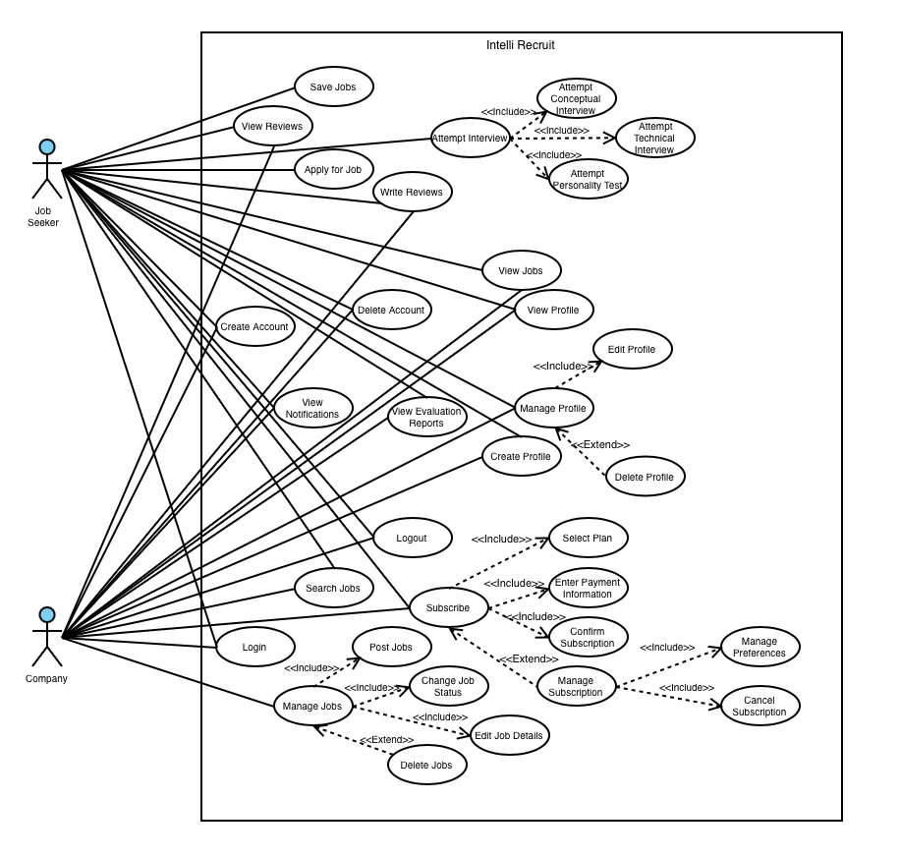

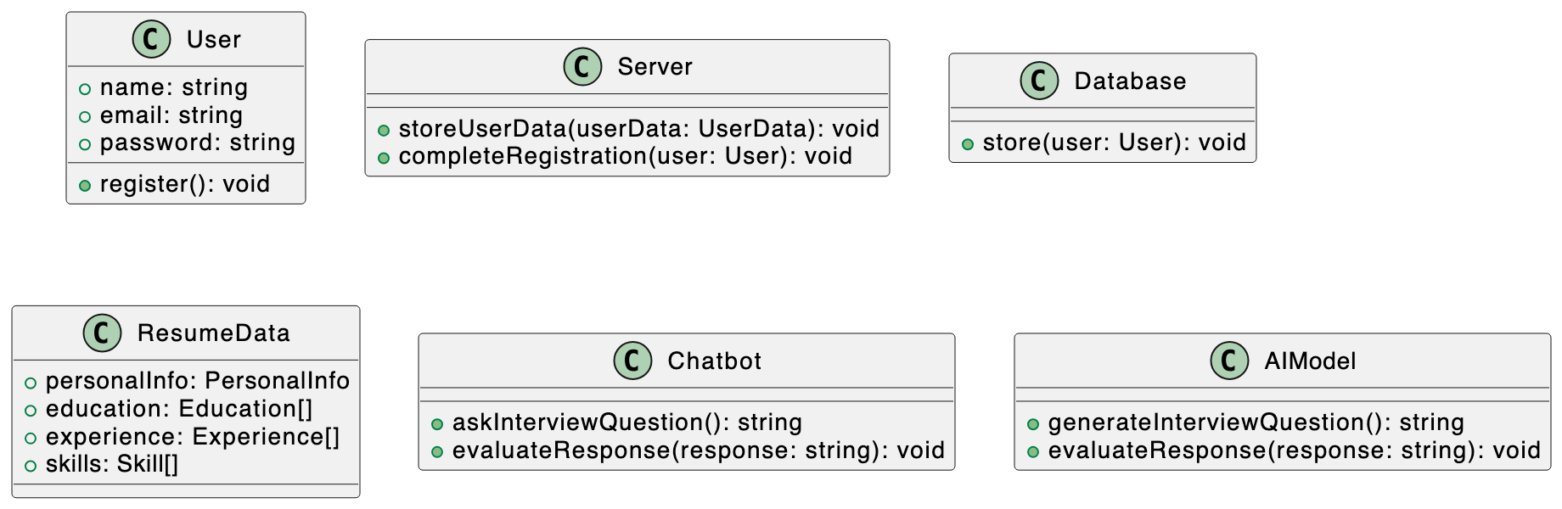**2. Logical View**

**3. Process View**

* **Recruitee**

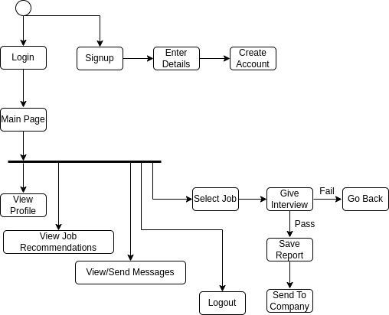

* **Recruiter**

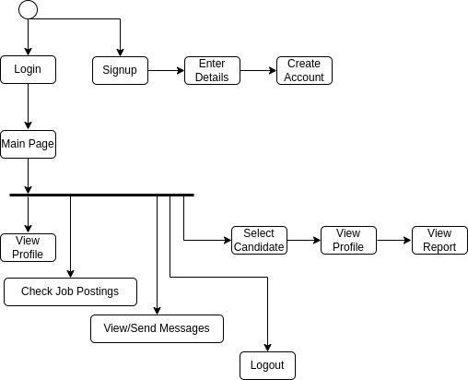

**4. Deployment View**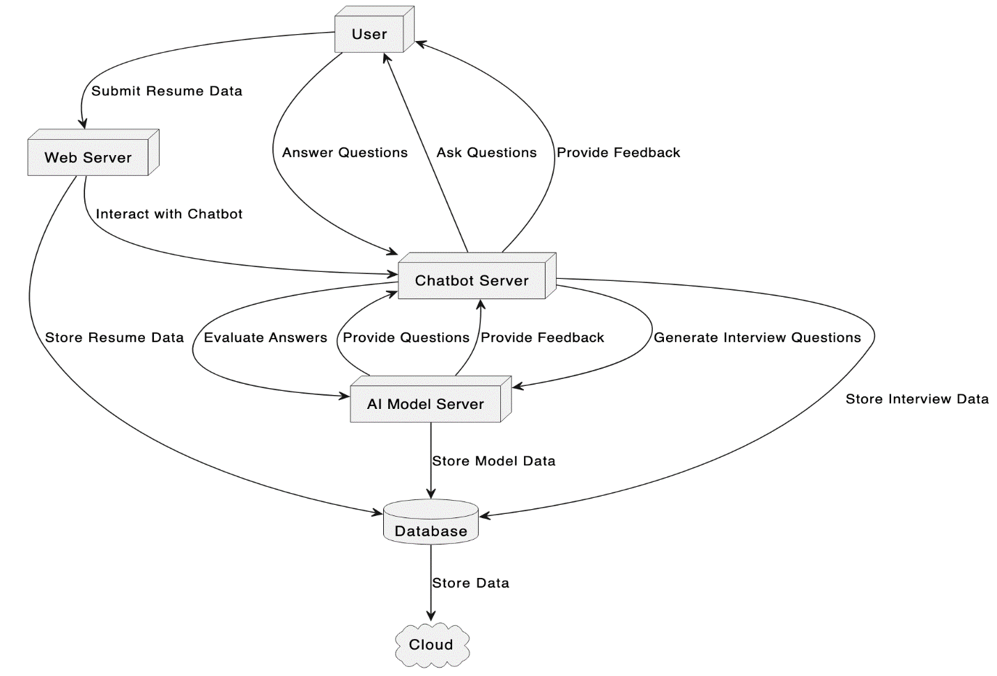

**5. Physical View**

**6. User Interface Design**

**Recruiter View:**

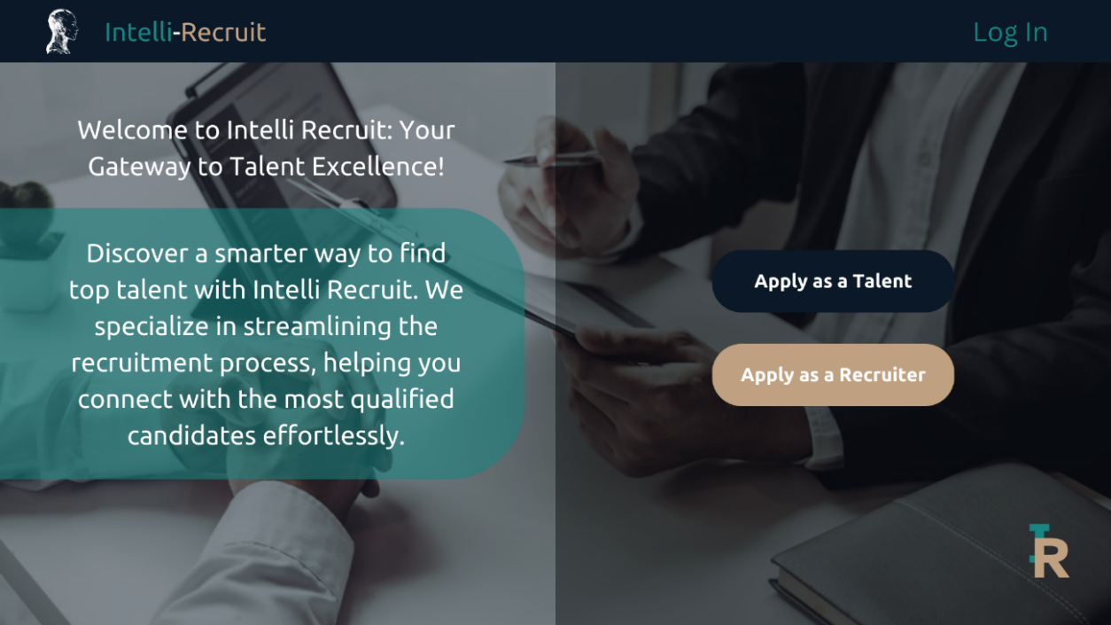**1. Landing Page**

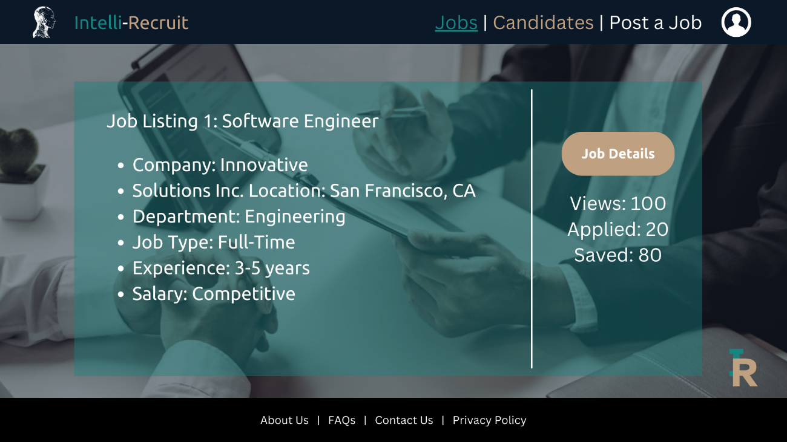**2. Main Page**

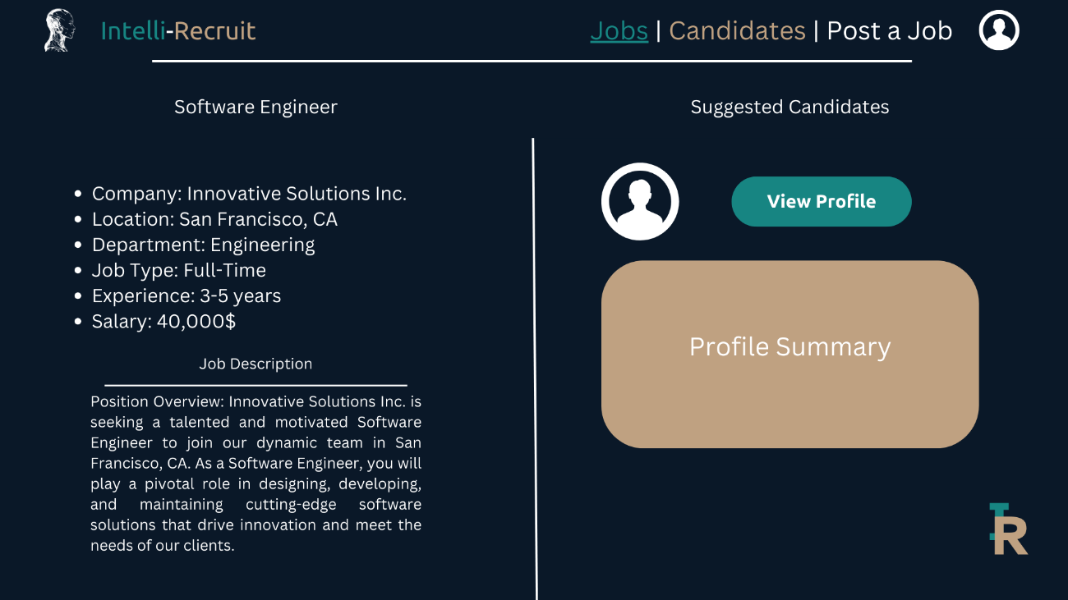**3. Job Details Page**

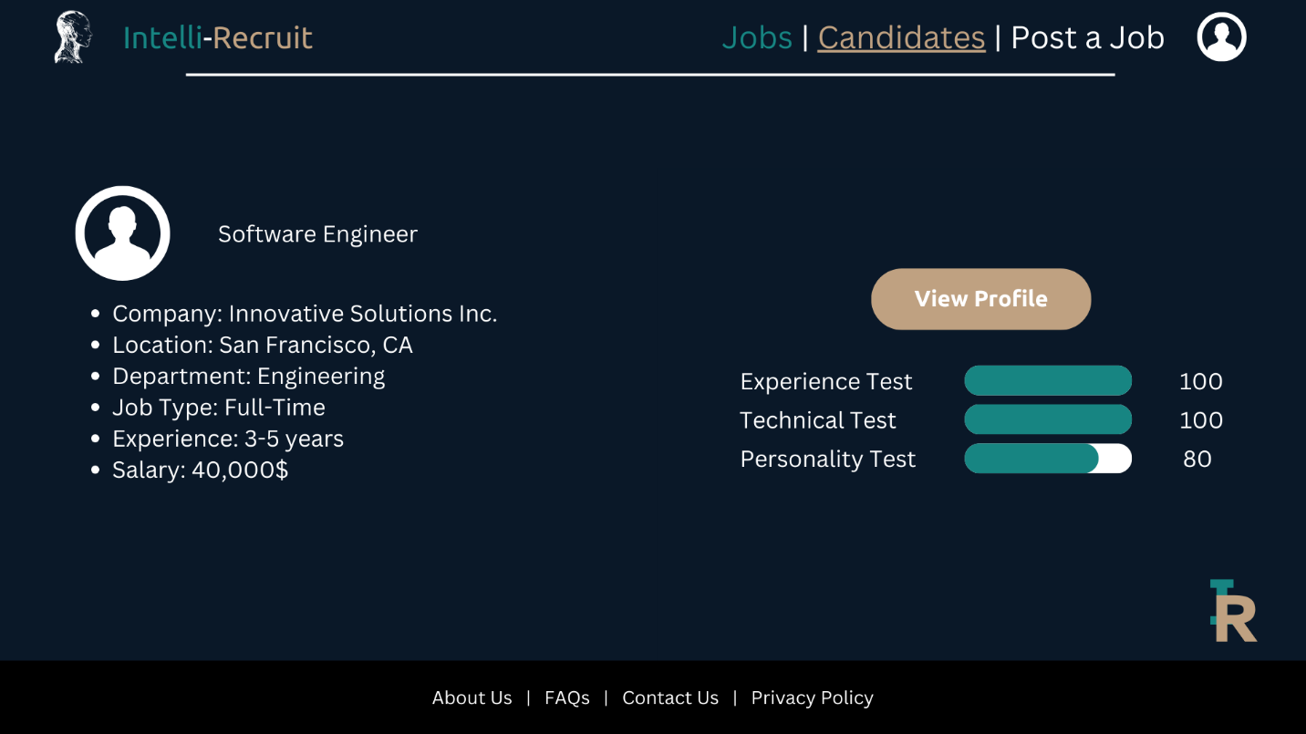**4. Applicant Profile View Page**

**5. Profile Page**

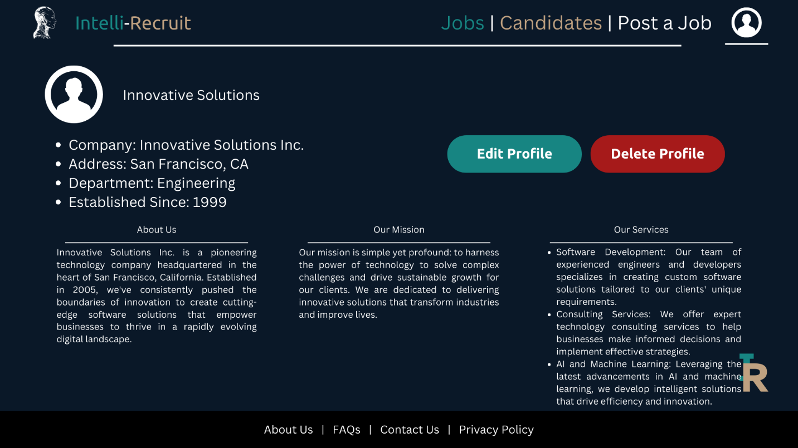

**Applicant/Recruitee**

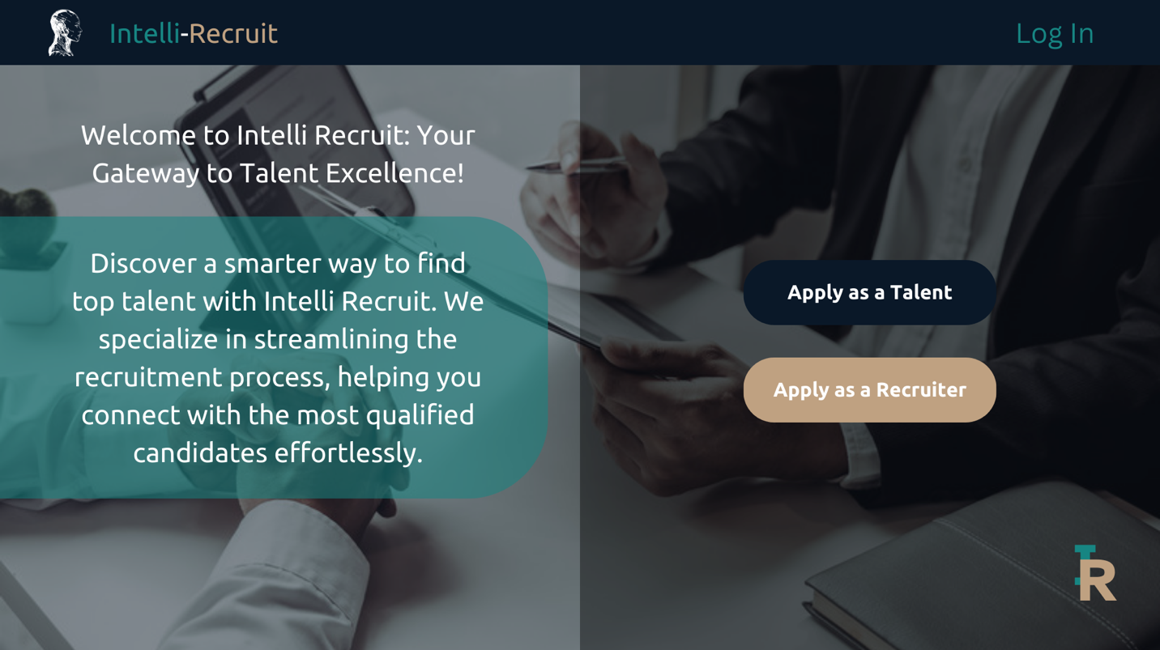**1. Landing Page**

**2. Main Page**

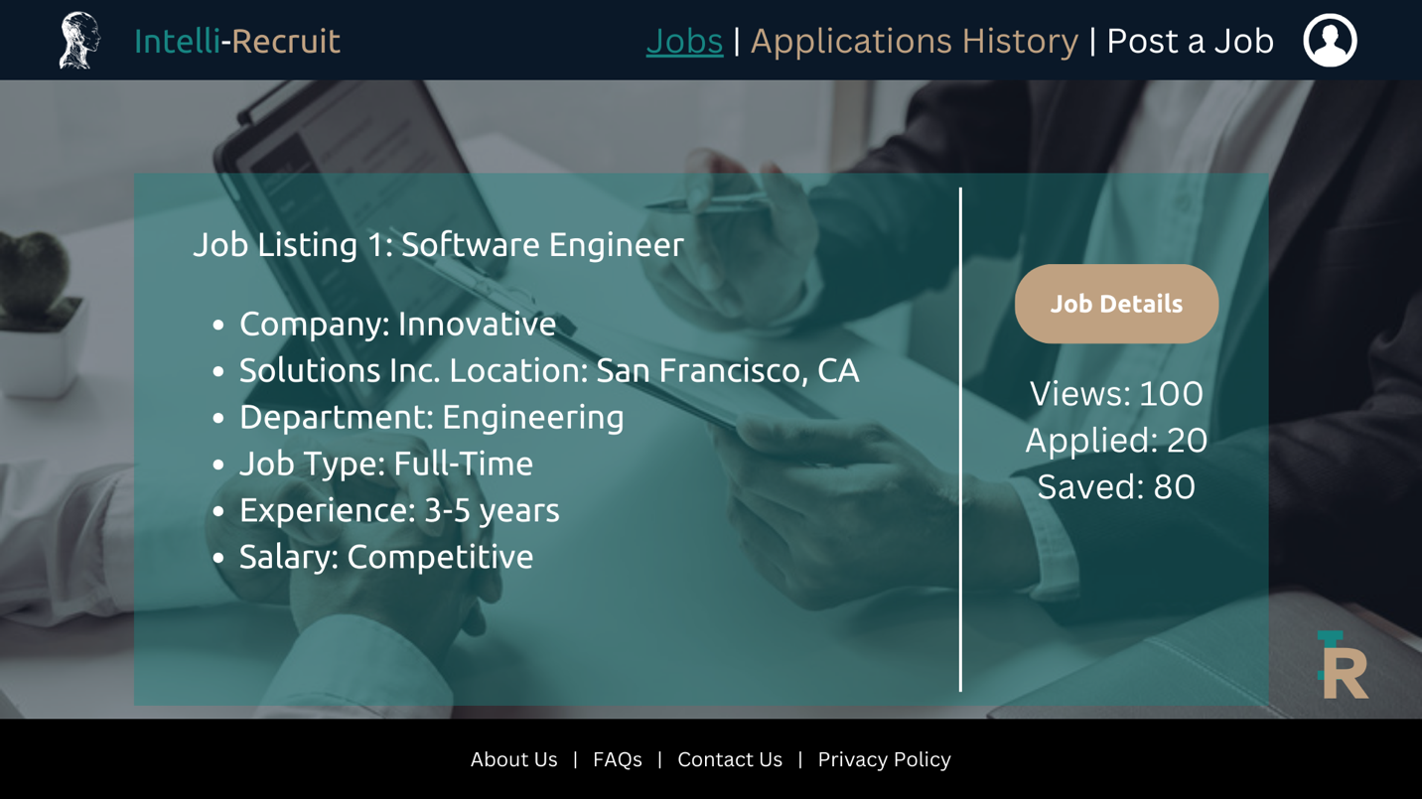

**3. Applied Jobs Page**

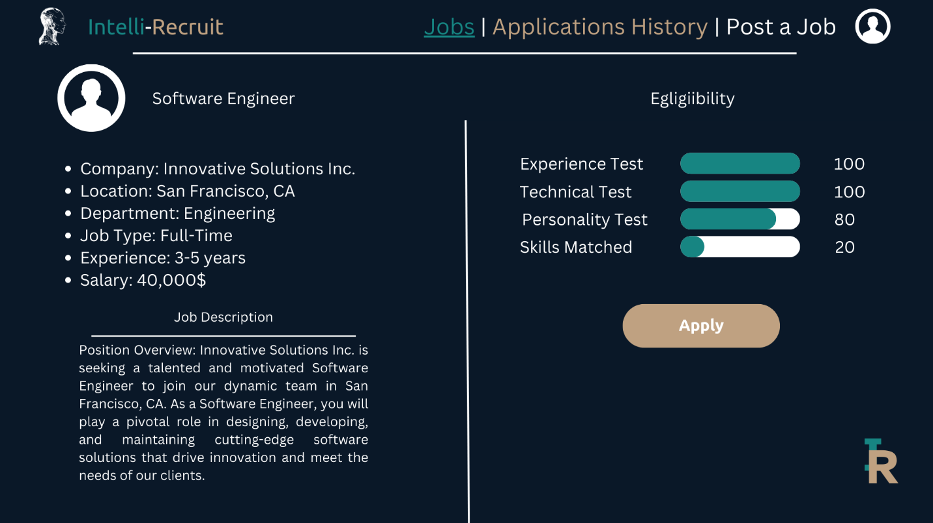

**4. Interview Page**

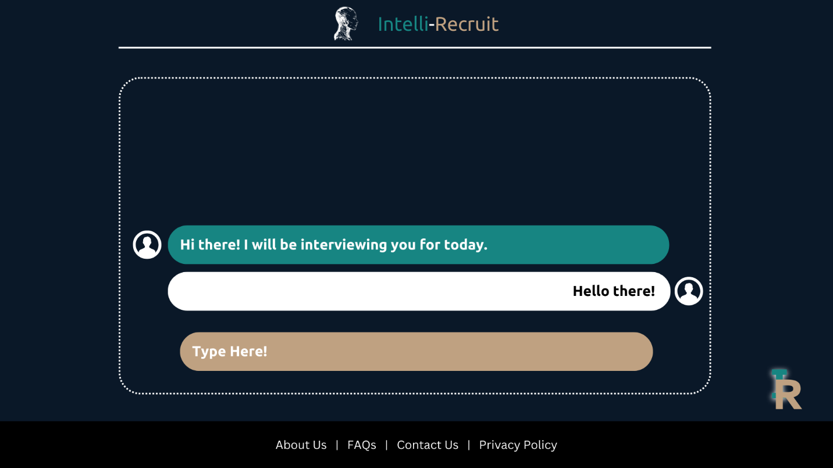

**5. Profile Page**

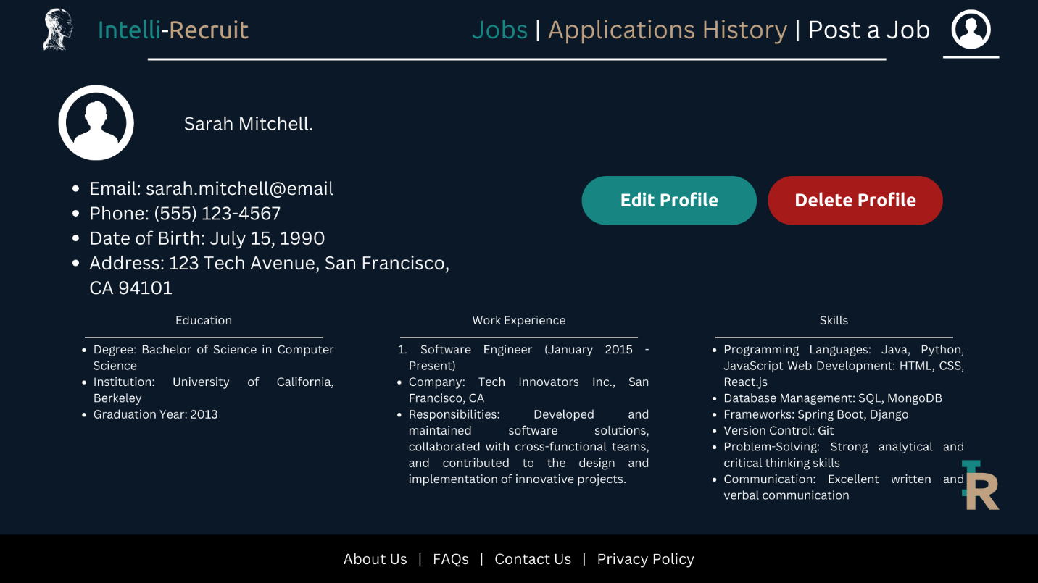

**Wireframes/Mockups:**

<https://www.figma.com/proto/v8vqrzz472FNK6GQRcVRL1/SRS-UI?type=design&node-id=5-31&t=OC3gb27elAEEMBAK-1&scaling=scale-down&page-id=0%3A1&starting-point-node-id=5%3A31&mode=design>

# References

AbdElminaam, D. S. (2021). HR-chat bot: Designing and building effective interview chat-bots for fake CV detection. *2021 International Mobile, Intelligent, and Ubiquitous Computing Conference (MIUCC).* *403-408.* IEE.

Aydın, E. &. (2023). An AI-Based Shortlisting Model for Sustainability of Human Resource Management. *Sustainability, 15*(3), 2737.

Dr. S.K Wagh, J. C. (2019). Automated Interview Evaluation using Rule based Chatbot . *Journal of Emerging Technologies and Innovative Research, 6*(5), -.

Mhadgut, S. K. (2022). vRecruit: An Automated Smart Recruitment Webapp using Machine Learning. *2022 International Conference on Innovative Trends in Information Technology (ICITIIT)* (pp. 1-6). IEEE.

Purohit, J. B. (2019). Natural language processing based jaro-the interviewing chatbot. *2019 3rd International Conference on Computing Methodologies and Communication (ICCMC)* (pp. 134-136). IEEE.

Siswanto, J. S. (2022). Interview Bot Development with Natural Language Processing and Machine Learning. *International Journal of Technology, 13*(2), 274-285.

Stanica, I. D. (2018). VR job interview simulator: Where virtual reality meets artificial intelligence for education. *Zooming Innovation in Consumer Technologies Conference (ZINC)* (pp. 9-12). IEEE.

Suakanto, S. S. (2021). Interview Bot for Improving Human Resource Management. Year: 2021. *2021 International Conference on ICT for Smart Society (ICISS)* (pp. 1-5). IEE.